User experience assessment

Wells International College

Hoang Ngan Vu

18156

|  |  |  |  |
| --- | --- | --- | --- |
| Name of Student | Hoang Ngan Vu | ID | 18156 |

**Assessment 1 – Project**

Contents

Project Background 2

Café Story 2

Café Statistic before 2020 Covid-19 pandemic 3

Task 1 3

Task 2 3

Task 3 4

Task 4 5

Task 5 5

Task 6 5

Task 7 6

Task 8 7

Index 7

***Instructions:***

The trainer may decide whether this will be an individual or group assessment.

In this project, you will need to perform various tasks related to interface design, user research, wireframing and prototyping for a web application according to the requirement specified in the project background.

***Duration:***

Trainer will set the duration of the assessment.

Please refer to my web design for this assessment:

<https://nganvu197.github.io/nganvu18156/>

**Your site needs a QR diagram, so users can easily access by phone.**

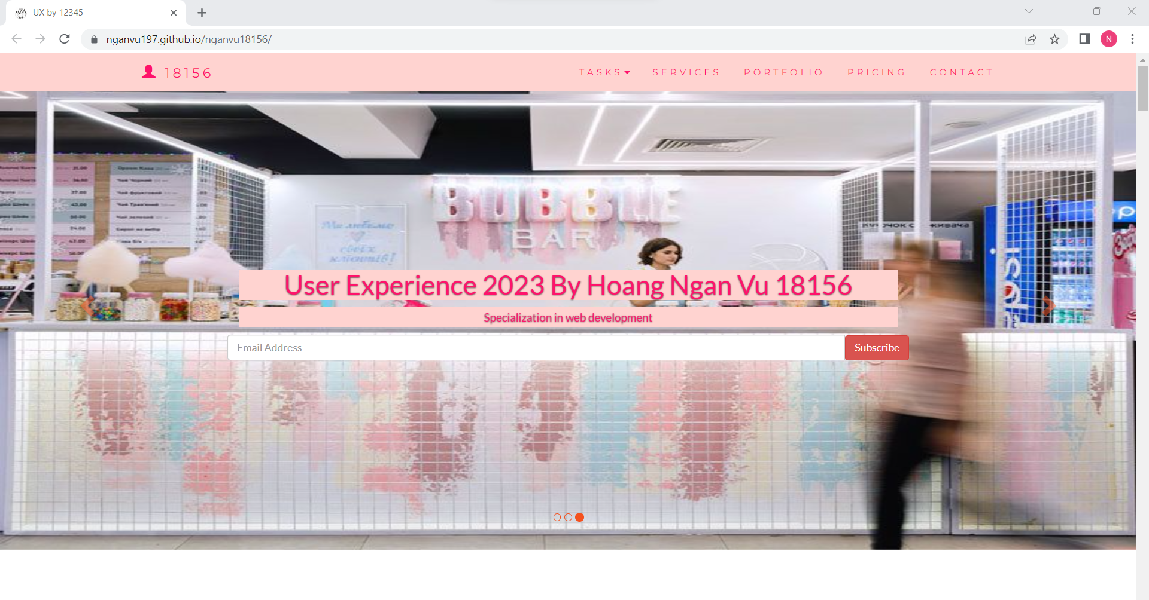

# Project Background

You are approached by the WIC Café to design a café website for their business. You can refer to denbisco.com or noccoffeeco.com as examples of café sites.

Here you could use any topic to develop your project! Here my example only shows web structure!

## Café Story

WIC Coffee’s inception was a childhood outdoor adventure amongst grandma's many fruit trees including the big-leafed and lofty liberica coffee. The cherries’ hues of red, the otherworldly complexion of the green beans, and the aroma of the roast are to be recalled much later through an espresso machine, a grinder, a modified popcorn machine and an insatiable desire to make better coffee.

A special tamper here, a special temperature probe there, joined the growing collection of equipment dedicated to the pursuit of great coffee. A small commercial roaster followed. Then a tiny café tucked away in a quaint suburb became the next outlet for the obsession. The few handfuls of beans at the beginning have turned into a hill of green.

But even great coffee can be made better.

So, the madness grows, along with the roaster, the coffee machine, Coffee Lover in Ultimo, WIC Cafe by Coffee Lover in World Square Complex, Micro cart Coffee in Crown Casino.

While we like to work quietly to the tune of our own roasting drums, we also garnered the Australian Barista

Champion title, Coffee Art Champion title, the NSW Championship titles, the inaugural Asia Pacific Cupping Champion title, the Coffee Guide Sydney "Haven Shot" plus 5 "coffee beans" Award in 2018 and 2019 and the "Best Coffee" award in the SMH Good Cafe Guide in 2017, 2018 & 2019.

The café is use to opened and served customer on the premises. During the Covid-19 pandemic, customers behaviour has been changed, sale record indicates that 60% sale dropping due to the restriction and social distancing regulation.

## Café Statistic before 2020 Covid-19 pandemic

Customer Age range

* 10-15 years 5%
* 16-25 years 20%
* 26-35 years 30%
* 36-45 years 30%
* Over 45 15%

Sale Record: average of 2875 cups per weeks Signature Coffee bean:

* Kenya Arabica beans
* Indonesia Arabica beans

Open Hours:

* Monday - Wednesday & Friday 7:00am - 5:15pm
* Thursday 7:00am - 6:15pm
* Saturday 8:00am - 4:15pm
* Sunday 10:00am - 2:45pm

I’ve decided to create a website for a bubble tea shop named Nana Sweet Tea Shop. Here’s the background info on it:

Nana Sweet Tea Shop, an Asian tea brand, is one of the leading and fastest expanding milk tea brands in Australia, with over 80 branches placed in key locations nationwide.

We are dedicated to make world-class products.

• Exclusive premium ingredients from Taiwan

• FDA accredited

• Consistent quality

• Exciting seasonal products created by in-house chefs

All tea shops are operated by Emerald Leaf Franchising Corporation or by its franchisees bound by franchise agreements. Nana Sweet operations are strenuously designed to provide consistent and quality service in every branch. Our stringent management system and dynamic team of market analysts, concept designers, and idea generators guarantee that our business flourishes.

While we're busy boba-ing, we've managed to win the Tearific Awards three consecutive years, 2021, 2022 and 2023. We're hoping for even better years to come.

**Your tasks:**

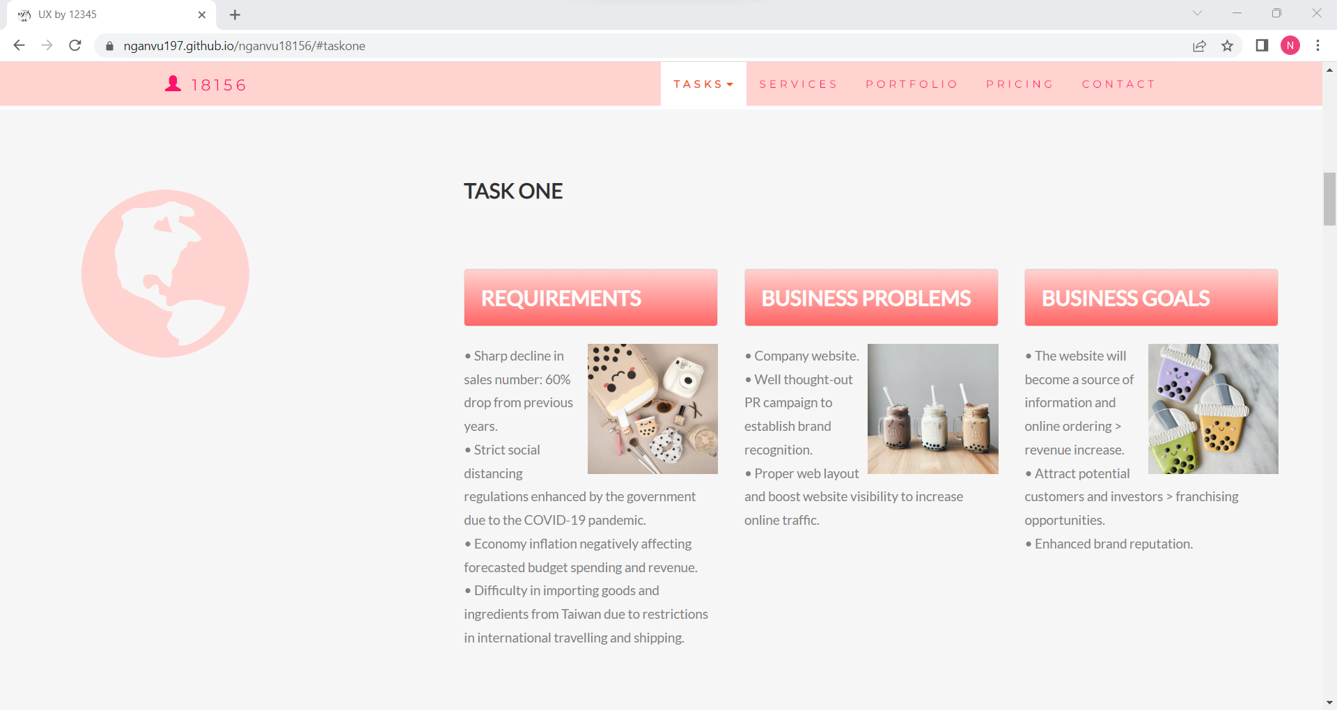

# Task 1

Analyse business requirement/needs and Identify business problem and goal.

Problems

* Sharp decline in sales number: 60% drop from previous years.
* Strict social distancing regulations enhanced by the government due to the COVID-19 pandemic.
* Economy inflation negatively affecting forecasted budget spending and revenue.
* Difficulty in importing goods and ingredients from Taiwan due to restrictions in international travelling and shipping.

Needs

* Company website.
* Well thought-out PR campaign to establish brand recognition.
* Proper web layout and boost website visibility to increase online traffic.

Goals

* The website will become a source of information and online ordering > revenue increase.
* Attract potential customers and investors > franchising opportunities.
* Enhanced brand reputation.

<https://nganvu197.github.io/nganvu18156/#taskone>

# Task 2

Select target user and develop 2 personas.

* Locals: Most constant type of customers, are usually households, tenants or business stakeholders around the area.
* Neighbourhood Frequents: Refers to people who spend a lot of time in the neighbourhood, very much like the locals and will be using the goods and services businesses in the area provide. Are usually workers from nearby offices, construction sites, factories or students from nearby schools.
* Tourists: Very sporadic and are rarely returned customers. Tourists are usually expected during high travel seasons; however, their sales are not guaranteed.

With that being said, all customers that adhere to the common etiquettes of business goers are absolutely welcome at Nana Sweet Tea Shop. The website can also be accessed any time of the day, 7 days a week.

<https://nganvu197.github.io/nganvu18156/#tasktwo>

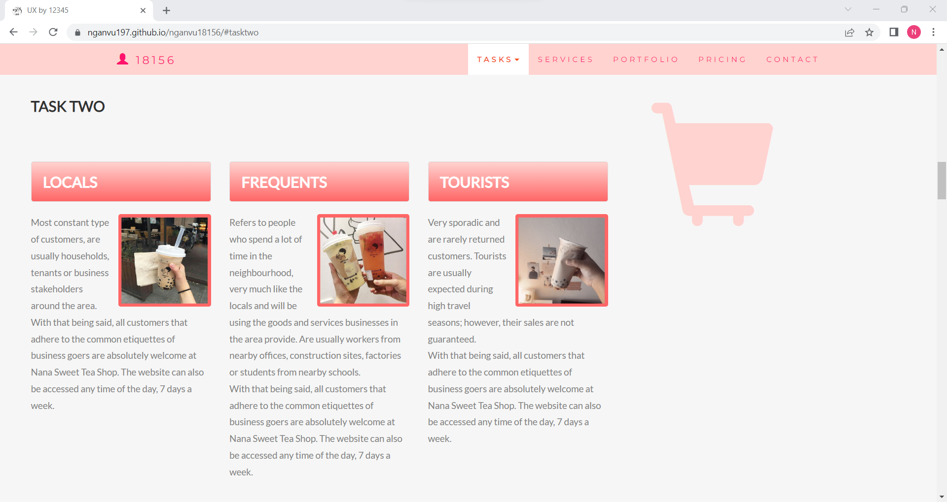

# Task 3

1. Develop WIC Café wireframe and present to trainer. The wireframe has to illustrate all pages for the café website. Website specification as following:

The website includes mostly of the following sections:

* + Home
  + About us
  + Tasks
  + Products
  + Contact us
  + Pricing
  + Portfolio
  + Locations
  + Customer feedback

The screenshots below show how each section looks like:

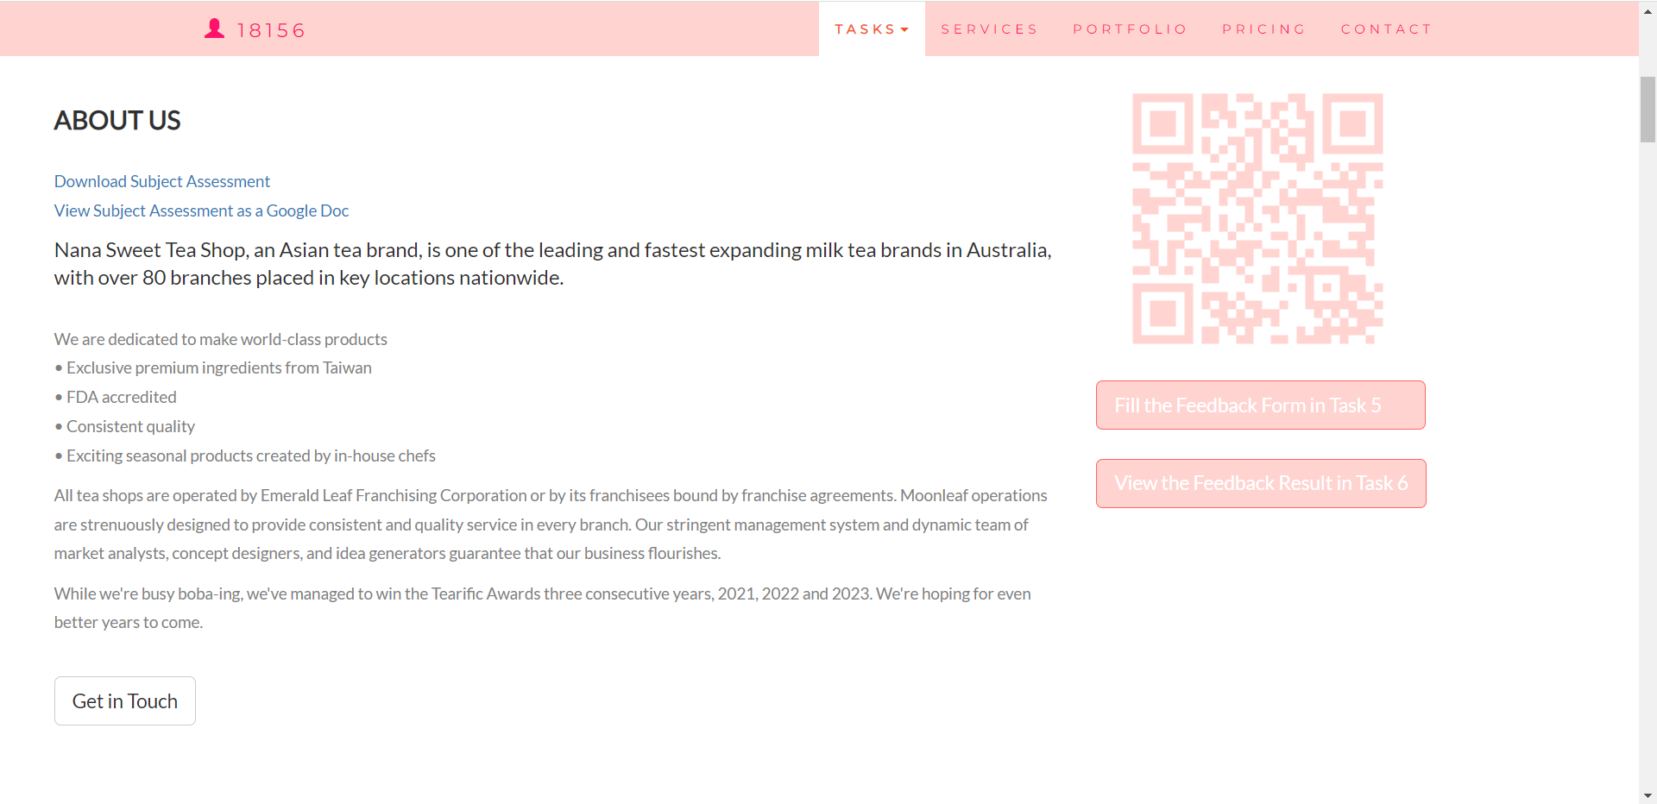

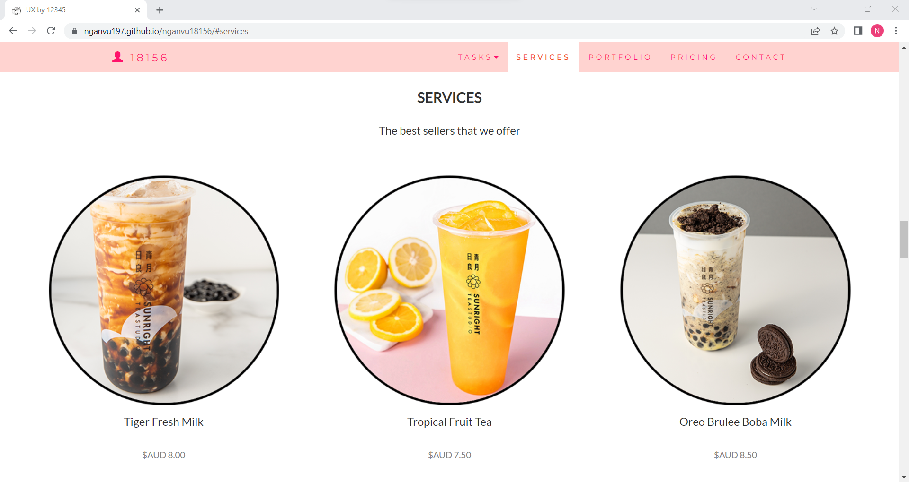

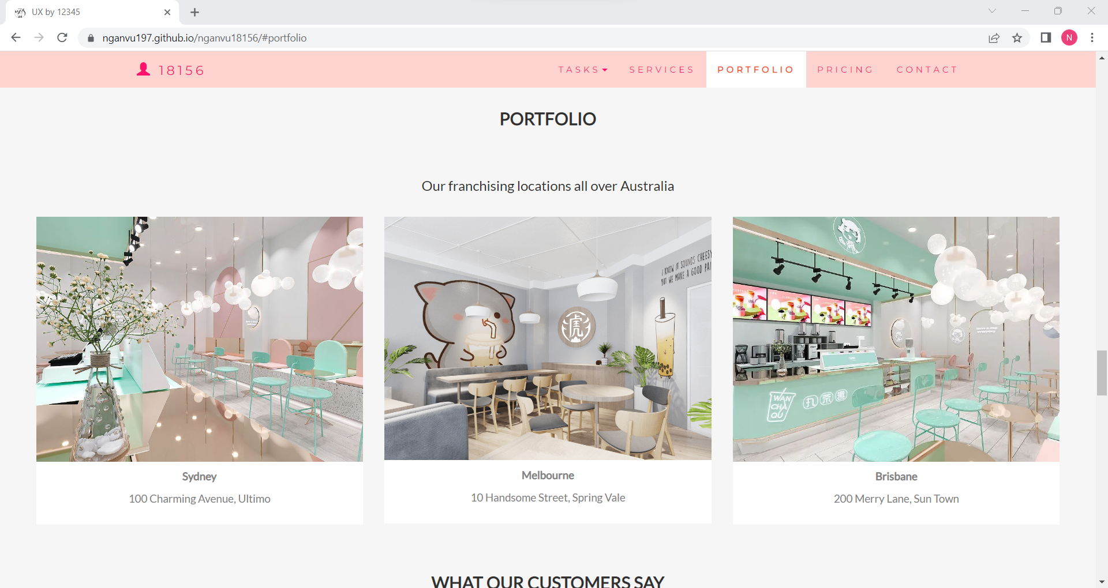 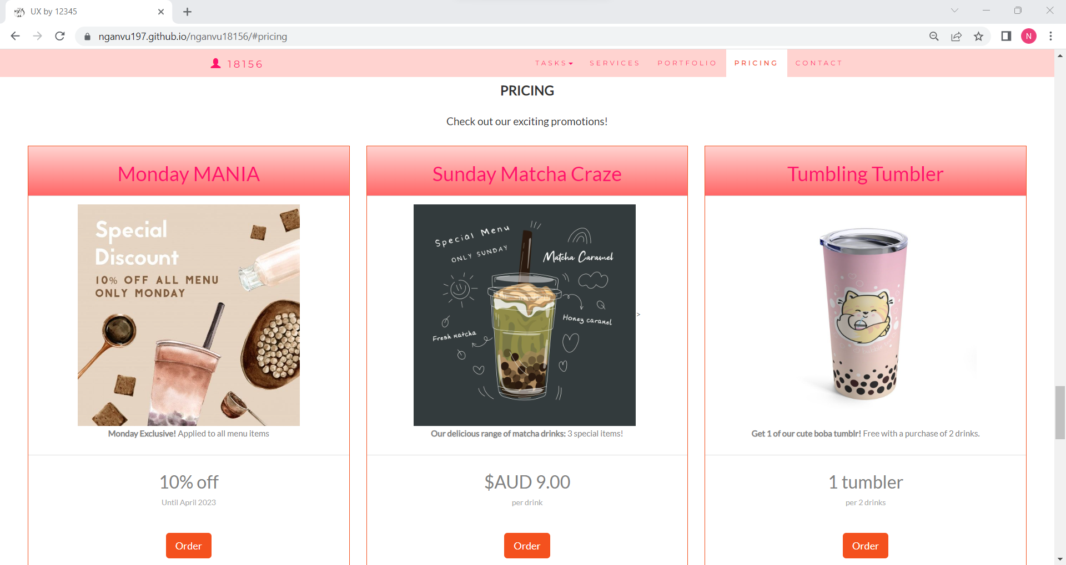 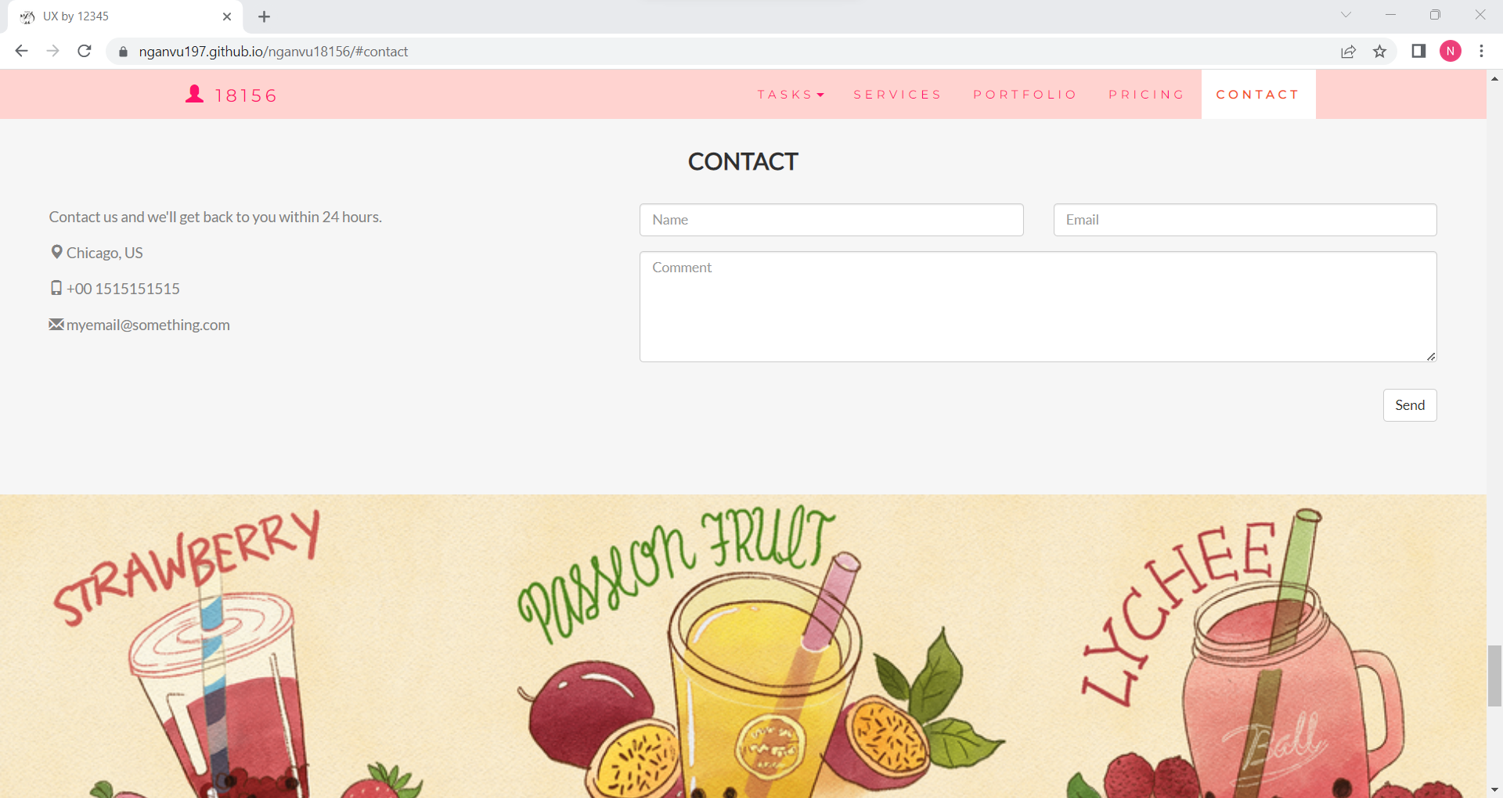

1. Amended the design from trainer feedback (if required). Then develop a digital prototype.

A survey was created and spread to gain opinions and suggestions from customers to improve the website. The actual form and responses can be viewed via the following URLs in order:

<https://docs.google.com/forms/d/e/1FAIpQLSerEmlXukGzSkBtx2ZRFJeiyxO8hLRKMtlIEF2hxmpkFnuUzg/viewform?usp=sf_link>

<https://docs.google.com/spreadsheets/d/1EG3hg6pS05HtatXhCcRfuQotD3tINsWafEvS8O4X9u4/edit?usp=sharing>

# Task 4

Develop a usability testing plan.

The survey was created via Google Form to gather feedback and recommendations. We focus on gathering their source of searching for the website, their favourite parts and possible suggestions.

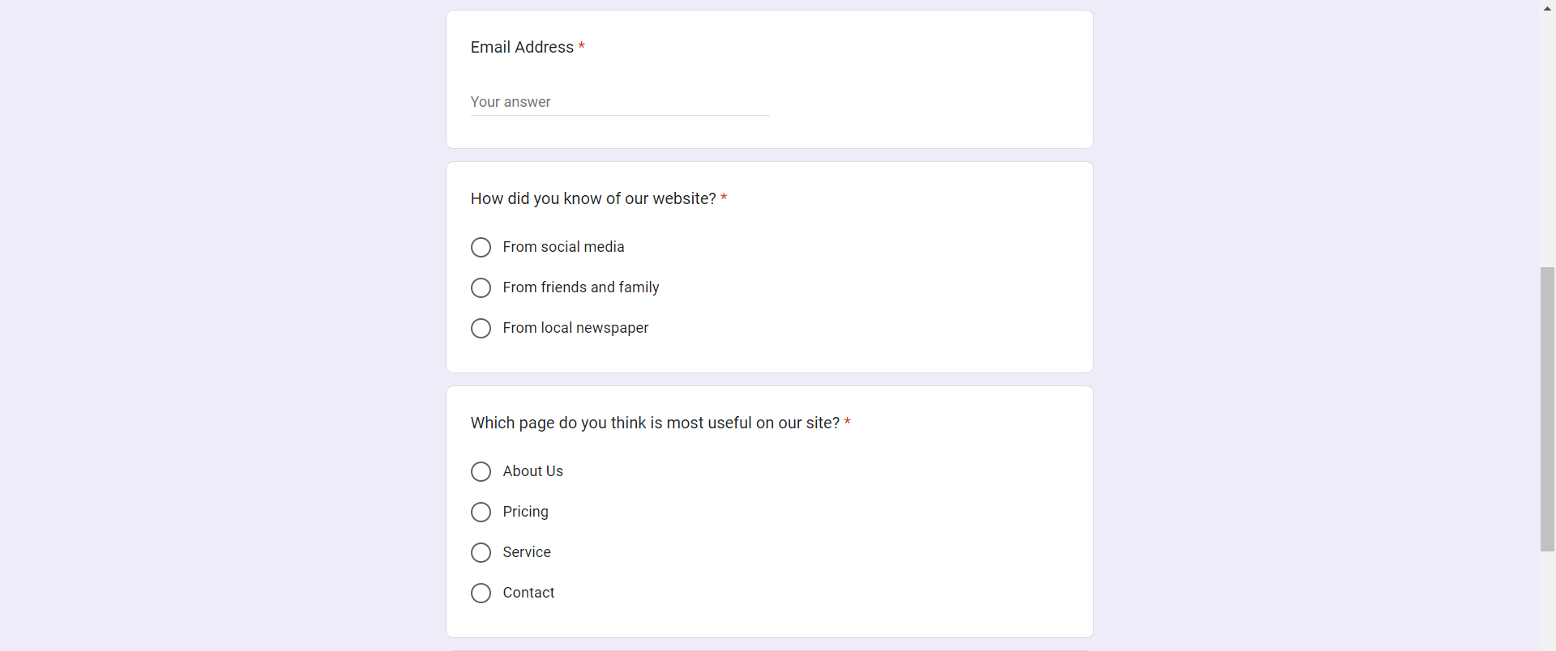 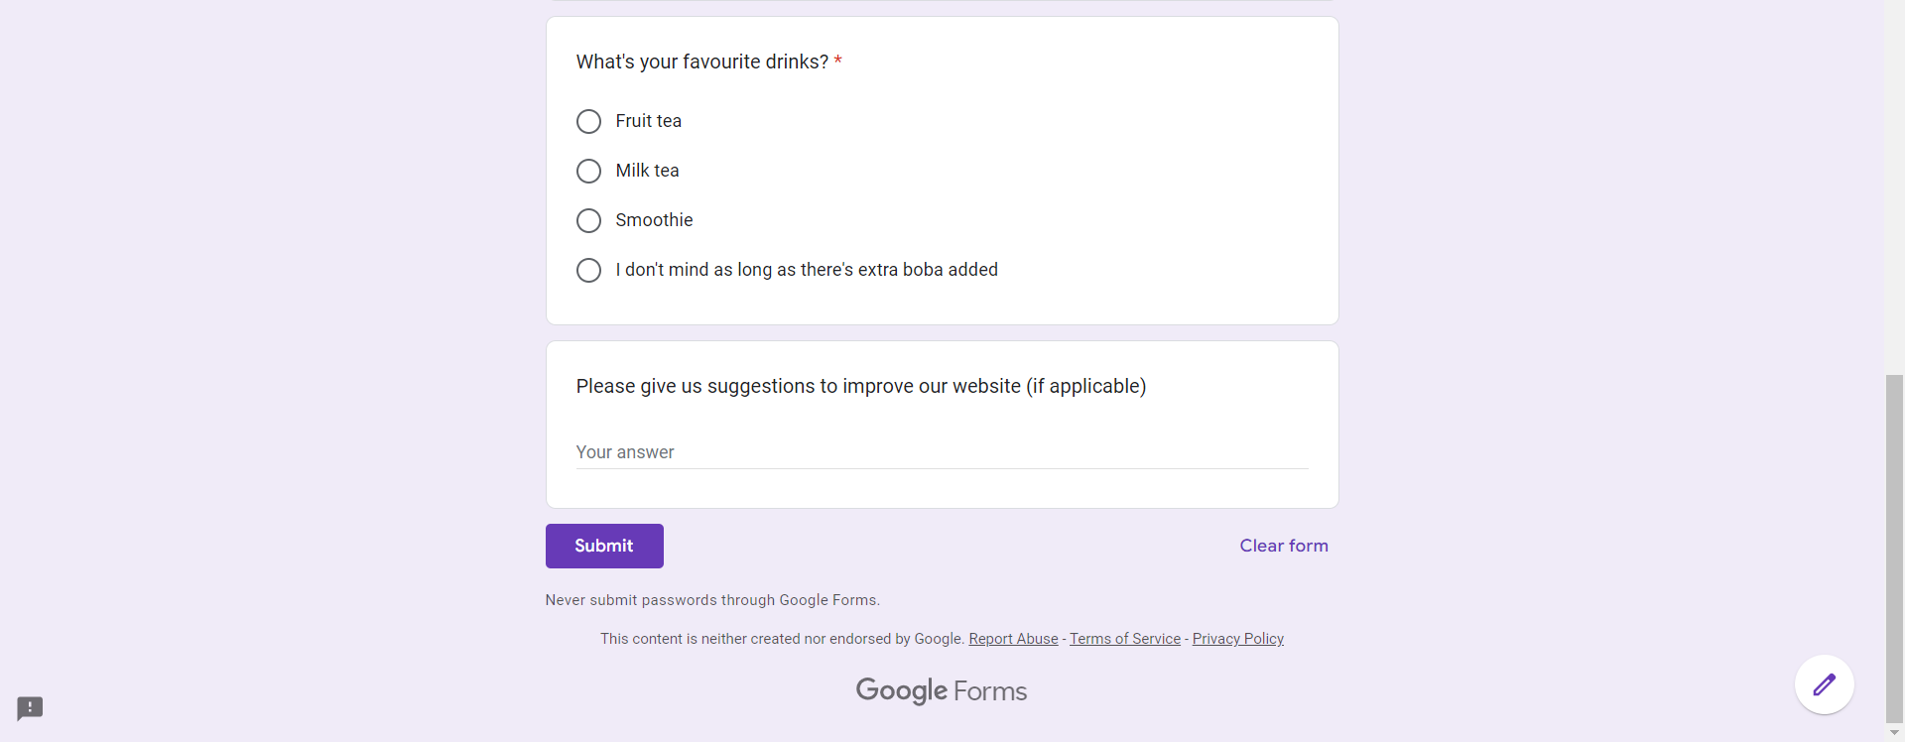

# Task 5

Conduct usability with at least 6 target users and gather the result.

The survey gathered a total of 6 responses, all of them answer the required fields and also kindly provide suggestions to better the website.

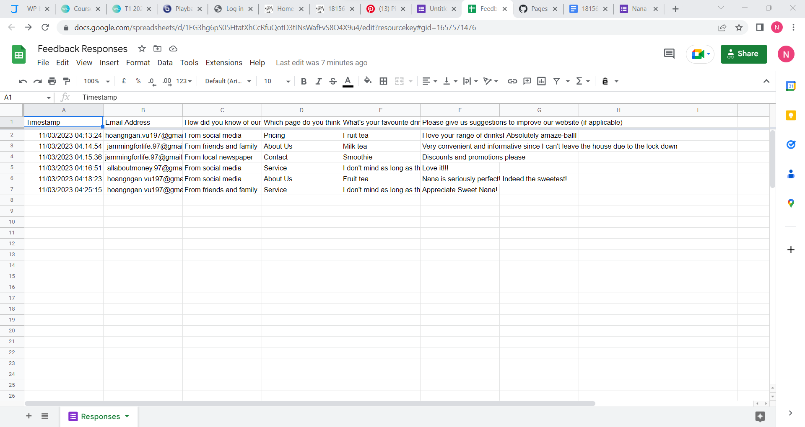

# Task 6

1. Evaluate test result and prepare the summary.

The overall results are mostly positive with many participants considered the website to be an excellent source of information and a convenient stop for bubble tea.

1. Highlight an abnormal value and discuss possible reason.

The participants however suggested that further discounts and promotions need to be added so customers are aware of possible deals.

If customers are looking for info on the tea shop online, they will obviously prefer being aware of any current deals we have in store, hence the need to have them updated on the website. Additionally, the economic inflation has taken a toll on our customers’ financial situation, therefore promotions are highly encouraged.

1. Summary change or improvement will be applied on the prototype and get approve from your trainer.

Use the feedback to continually improve the website, add additional contents as per recommendations and potentially increase sales.

# Task 7

1. Identify and develop quality assurance process for the café website and perform quality assurance test.

The below is our quality insurance checklist for the new tea shop website.

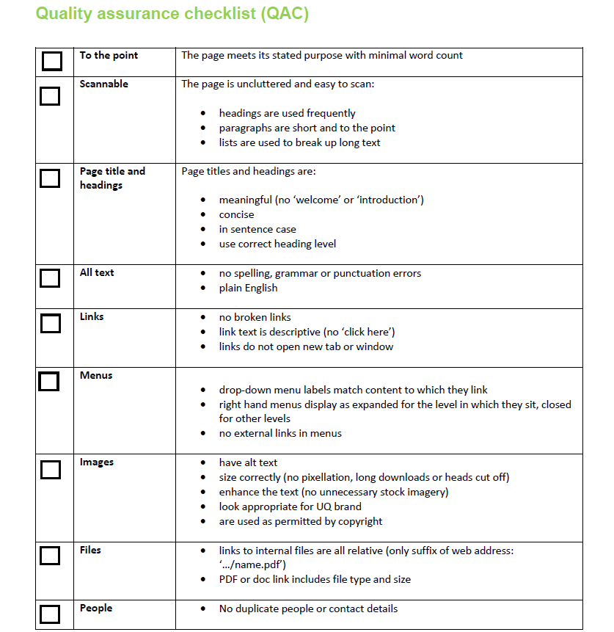

1. Develop QA checklist and completed the test.

Will be conducted using the above checklist.

1. Conduct QA testing and completed the check list.   
   Will be conducted using the above checklist.

# Task 8

Organize documentation for all the above-mentioned tasks with screen shots or evidence photo (if applicable) and prepare a report following a report writing standard to submit to your trainer.

My site is responsive, so you can easily view the mobile phone version:

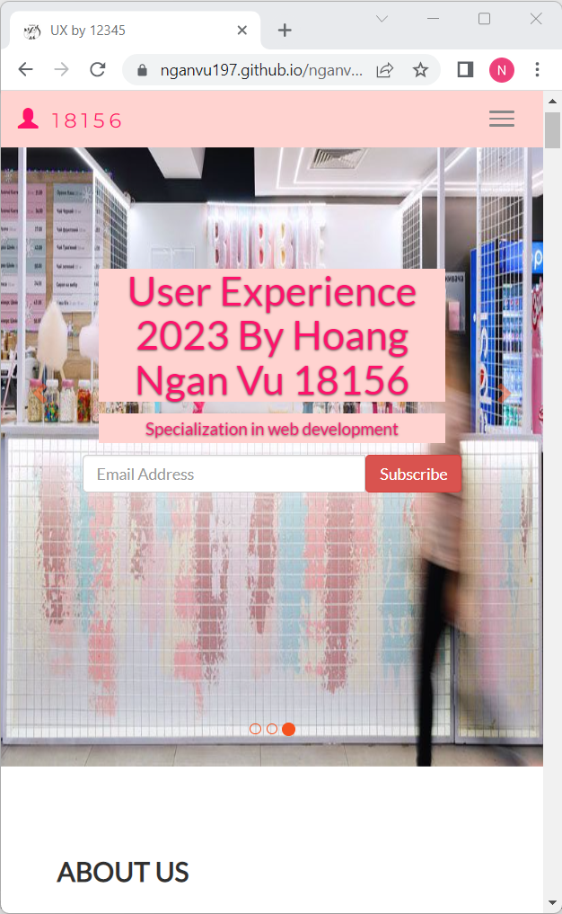

My website can either be viewed using the QR code, or via the URL below:

<https://nganvu197.github.io/nganvu18156/#myPage>

# Index

B

business requirement 3

D

Develop WIC Café 4

distancing regulation 2

G

Google form 5

W

WIC Café website 3

WIC Coffee’s 2